In the name of god







***Producers :***

*Sayyed Hossein Hosseini*

***Supervisor :***

*Dr Mohammad Reza Sharbaf*

***Teacher assistant :***

*Reza Pour Mohammadi*

***Faculty of Computer Engineering, University of Isfahan***

***Autumn 2023***

Table of Contents

**Microsoft Project1**

Change Working Time1

### microsoft project :

First, let's have a general introduction about this program so that we can look at the process of working with the program with a more open view.

This program is one of the most demanded project management programs and it is possible to break the programs into small tasks and assign the tasks to a number of people according to the schedule.

Then we see that the Gantt chart will be drawn in front of us in half of the page and it shows the relationship between tasks and people.

Also, the timeline is placed at the top of the screen and shows how our process is progressing according to the schedule.

Now we go to the project implementation process :

### change working time :

First, according to the procedure, this option can be seen on the top bar in the project section :

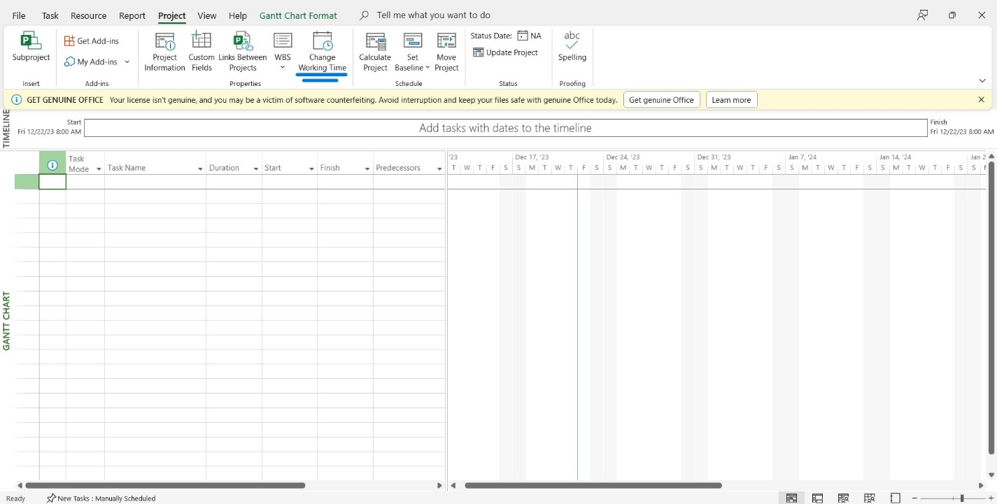

1

Then, after selecting and clicking on the desired icon in the opened window, create a calendar with the desired name so that we can apply our preferences :

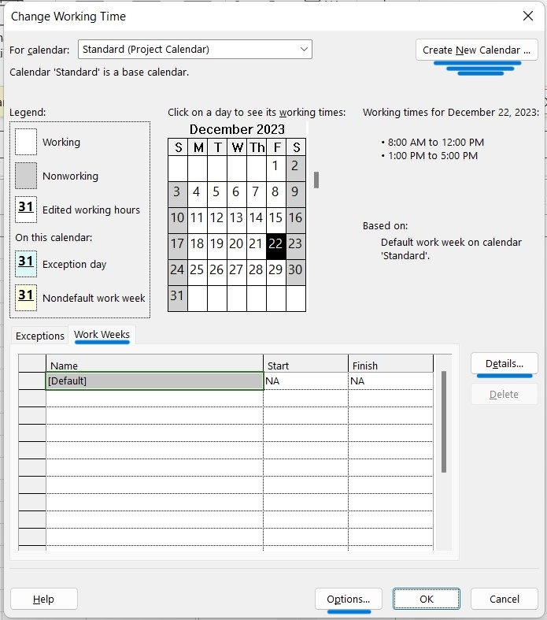

2

After creating the calendar, one item can be seen by default from the Work Weeks section, and then we will check the details section :

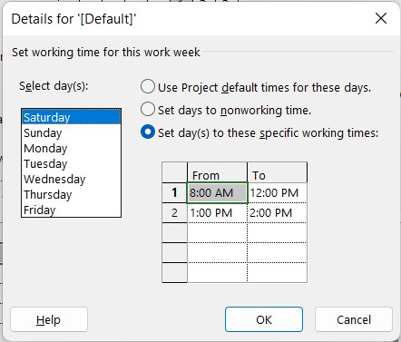

Here, according to the desired picture, we specify the working hours and the closed times to be applied in the schedule, and then in the option section at the bottom of the page, we need to change a series of events according to our wishes in order to apply the changes correctly. to be :

3

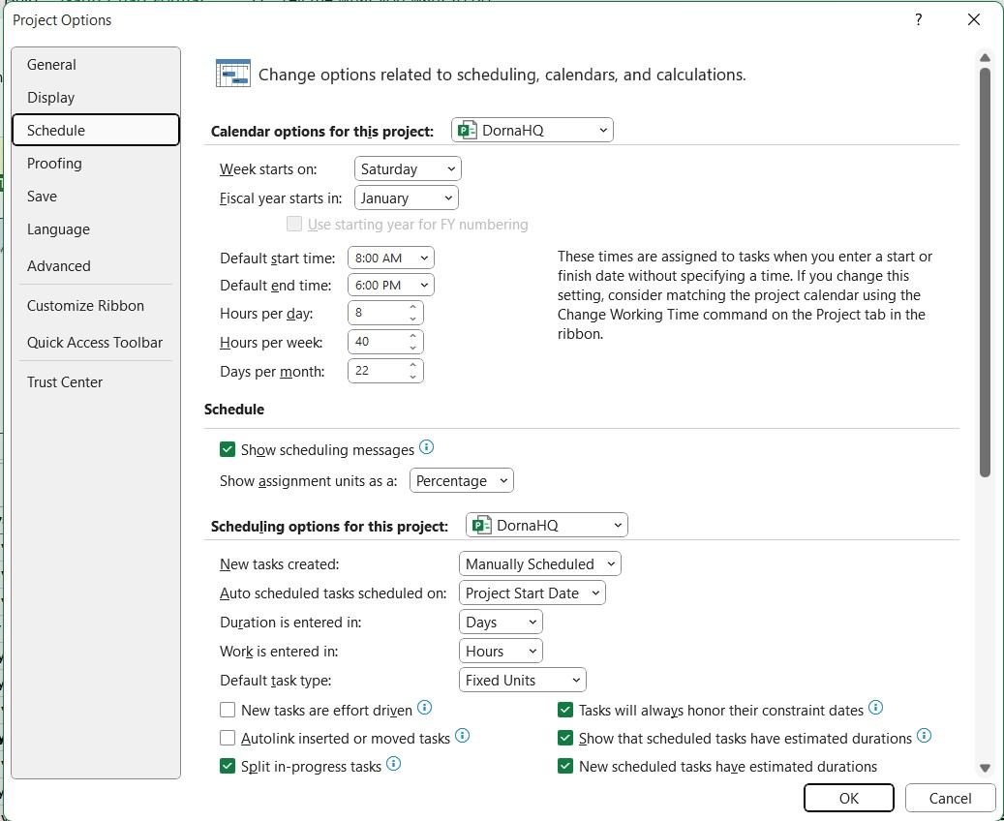

Then, in the calendar option for this project section, we apply our desired changes, such as the start time of the week and working hours per day, etc.

Our work in this part is finished and we have created our desired calendar.

***See attached project for full details***

4